***5 April 2022***

***1NT19IS135***

***SAHANA.V***

***C1 BATCH***

***MONGO DB***

* ***MongoDB is a non-relational document database that provides support for JSON-like storage. The MongoDB database has a flexible data model that enables you to store unstructured data, and it provides full indexing support, and replication with rich and***

***intuitive APIs.***

* ***Using mongo -version : this gives the shell version and its build information.***

***Mongo : connects to mongodb***

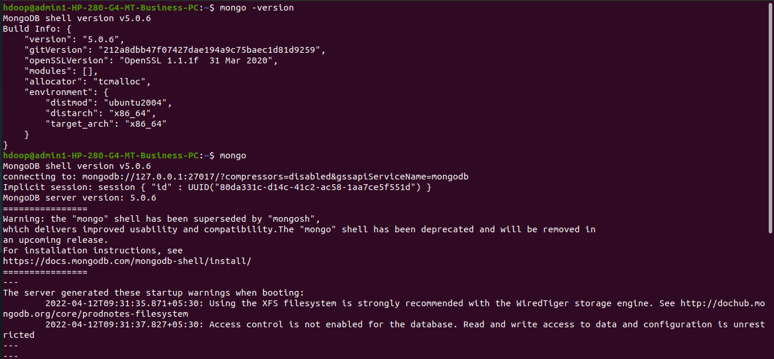

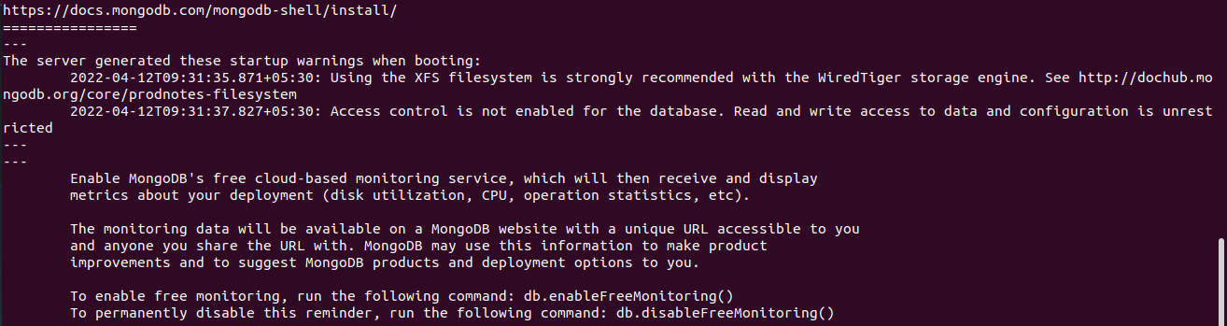

* **There is no “create” command in the MongoDB shell. In order to create a database, you will first need to switch the context to a non-existing database using the use command:**



* **To add a document to your database, use the db.collection_name.insertOne command**
* **MongoDB only creates the database when you first store data in that database. This data could be a collection or even a document**

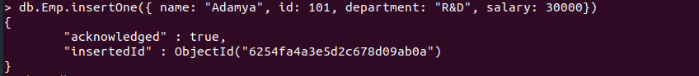

* **show dbs command displays all the database that are present.**

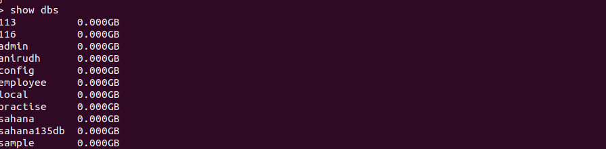

* **The find() method returns a cursor to the results**



* **db.collection.insertMany() can be used insider multi-document transactions.**
* **Used to inert many records at a single time.**

